Name: Nguyễn Đình Khánh Vy
Section: 22161043
Laboratory Exercise 3
DISCRETE-TIME SIGNALS: FREQUENCY-DOMAIN REPRESENTATIONS
3.1 DISCRETE-TIME FOURIER TRANSFORM
Project 3.1 DTFT Computation
A copy of Program P3_1 is given below:
% Program P3_1
% Evaluation of the DTFT
clf;
% Compute the frequency samples of the DTFT
w = -4*pi:8*pi/511:4*pi;
num = [2 1];den = [1 -0.6];
h = freqz(num, den, w);
% Plot the DTFT
subplot(2,1,1)
plot(w/pi,real(h));grid
title('Real part of H(e^{j\omega})')
xlabel('\omega /\pi');
ylabel('Amplitude');
subplot(2,1,2)
plot(w/pi,imag(h));grid
title('Imaginary part of H(e^{j\omega})')
xlabel('\omega /\pi');
ylabel('Amplitude');
pause
subplot(2,1,1)
plot(w/pi,abs(h));grid
title('Magnitude Spectrum |H(e^{j\omega})|')
xlabel('\omega /\pi');
ylabel('Amplitude');
subplot(2,1,2)
plot(w/pi,angle(h));grid
title('Phase Spectrum arg[H(e^{j\omega})]')
xlabel('\omega /\pi');
ylabel('Phase in radians');
Answers:
Q3.1 The expression of the DTFT being evaluated in Program P3_1 is
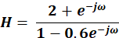
The function of the pause command is Pause playback or recording
Q3.2 The plots generated by running Program P3_1 are shown below:
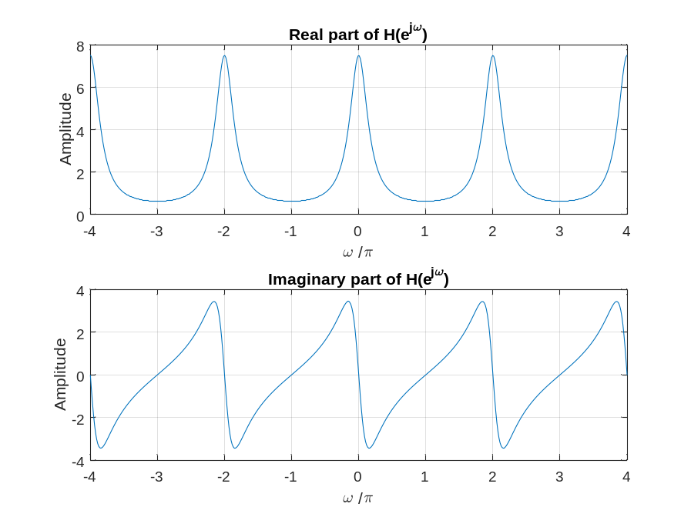
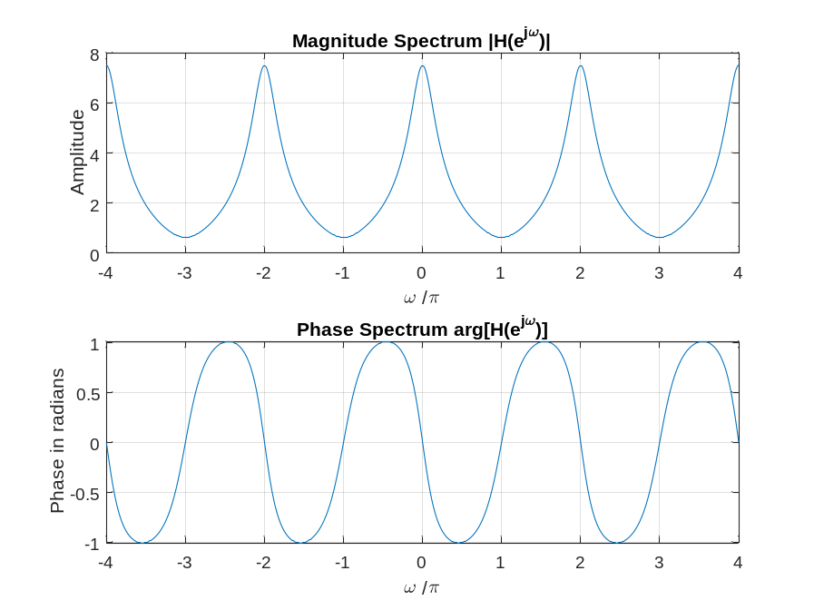
The DTFT is a periodic function of ω.
Its period is
The types of symmetries exhibited by the four plots are as follows:
- The real part is periodic and EVEN SYMMETRIC.
- The imaginary part is periodic and ODD SYMMETRIC.
- The magnitude is periodic and EVEN SYMMETRIC.
- The phase is periodic and ODD SYMMETRIC.
Q3.3 The required modifications to Program P3_1 to evaluate the given DTFT of Q3.3 are given below:
% Program Q303
% Evaluation of the DTFT
clf;
% Compute the frequency samples of the DTFT
w = 0:8*pi/511:pi;
num = [0.7 -0.5 0.3 1];
den = [1 0.3 -0.5 0.7];
h = freqz(num, den, w);
% Plot the DTFT
subplot(2,1,1)
plot(w/pi,real(h));grid
title('Real part of H(e^{j\omega})')
xlabel('\omega /\pi');
ylabel('Amplitude');
subplot(2,1,2)
plot(w/pi,imag(h));grid
title('Imaginary part of H(e^{j\omega})')
xlabel('\omega /\pi');
ylabel('Amplitude');
pause
subplot(2,1,1)
plot(w/pi,abs(h));grid
title('Magnitude Spectrum |H(e^{j\omega})|')
xlabel('\omega /\pi');
ylabel('Amplitude');
subplot(2,1,2)
plot(w/pi,unwarped(angle(h)));grid
title('Phase Spectrum arg[H(e^{j\omega})]')
xlabel('\omega /\pi');
ylabel('Phase in radians');

The plots generated by running the modified Program P3_1 are shown below:
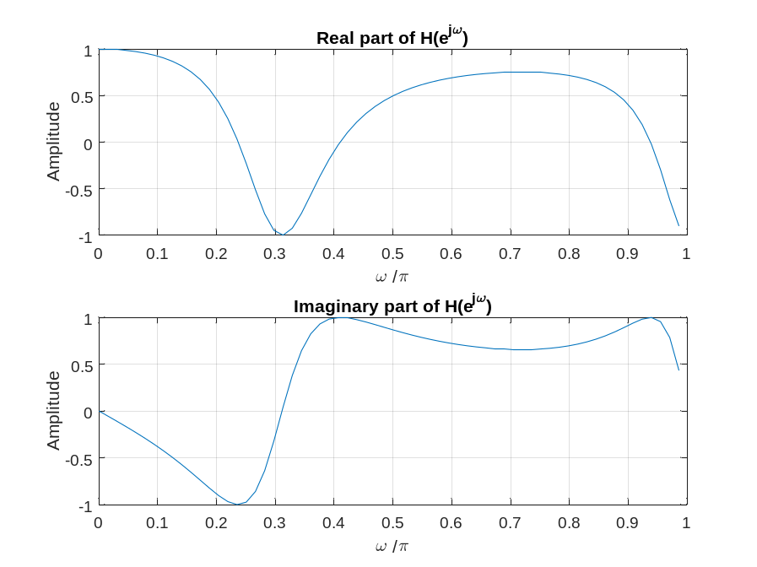
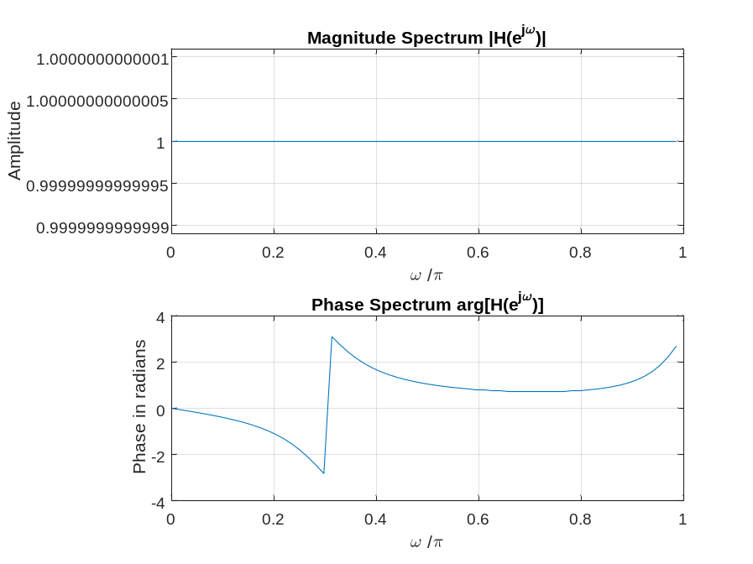
The DTFT is a periodic function of ω.
Its period is
The jump in the phase spectrum is caused by a branch cut in the arctan function used by angle in computing the phase. “angle” returns the principal branch of arctan
The phase spectrum evaluated with the jump removed by the command unwrap is as given below:
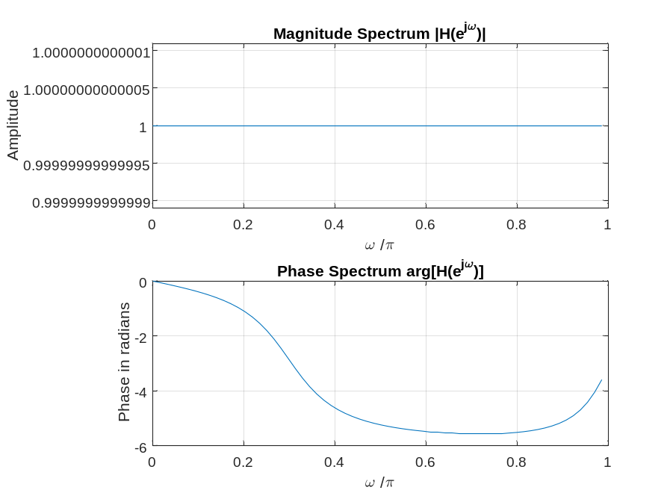
Q3.4 The required modifications to Program P3_1 to evaluate the given DTFT of Q3.4 are given below:
% Program Q304
% Evaluation of the DTFT
clf;
% Compute the frequency samples of the DTFT
w = -4*pi:8*pi/511:4*pi;
num = [1 3 5 7 9 11 13 15 17];
den = [1];
h = freqz(num, den, w);
% Plot the DTFT
subplot(2,1,1)
plot(w/pi,real(h));grid
title('Real part of H(e^{j\omega})')
xlabel('\omega /\pi');
ylabel('Amplitude');
subplot(2,1,2)
plot(w/pi,imag(h));grid
title('Imaginary part of H(e^{j\omega})')
xlabel('\omega /\pi');
ylabel('Amplitude');
pause
subplot(2,1,1)
plot(w/pi,abs(h));grid
title('Magnitude Spectrum |H(e^{j\omega})|')
xlabel('\omega /\pi');
ylabel('Amplitude');
subplot(2,1,2)
plot(w/pi,angle(h));grid
title('Phase Spectrum arg[H(e^{j\omega})]')
xlabel('\omega /\pi');
ylabel('Phase in radians');
The plots generated by running the modified Program P3_1 are shown below:
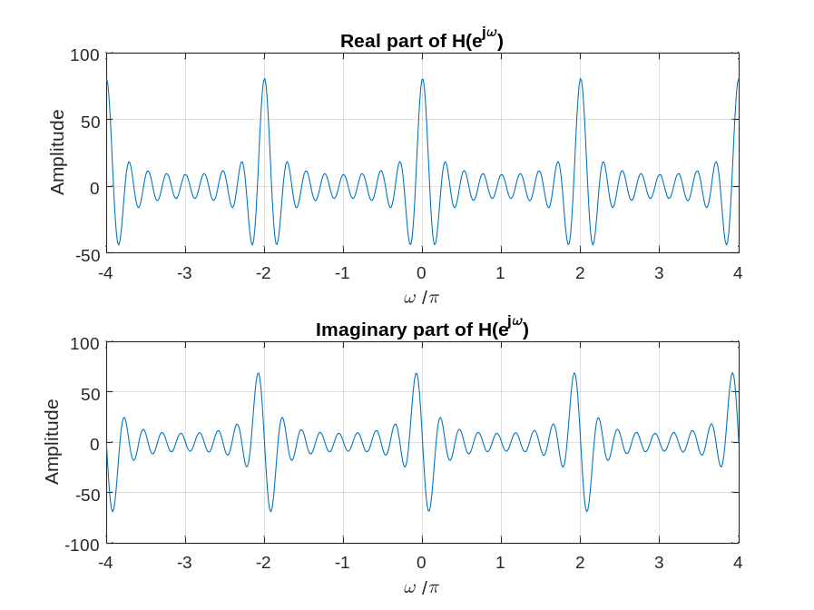
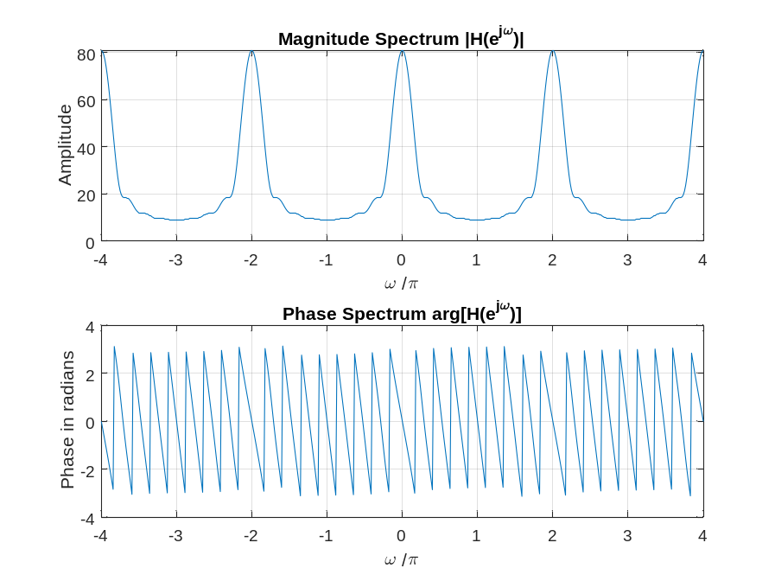
The DTFT is a periodic function of ω.
Its period is
The jump in the phase spectrum is caused by “angle” returns the principal value of the arc tangent.
Q3.5 The required modifications to Program P3_1 to plot the phase in degrees are indicated below:
% Program Q305
% Evaluation of the DTFT
clf;
% Compute the frequency samples of the DTFT
w = -4*pi:8*pi/511:4*pi;
num = [1 3 5 7 9 11 13 15 17];
den = [1];
h = freqz(num, den, w);
% Plot the DTFT
subplot(2,1,1)
plot(w/pi,real(h));grid
title('Real part of H(e^{j\omega})')
xlabel('\omega /\pi');
ylabel('Amplitude');
subplot(2,1,2)
plot(w/pi,imag(h));grid
title('Imaginary part of H(e^{j\omega})')
xlabel('\omega /\pi');
ylabel('Amplitude');
pause
subplot(2,1,1)
plot(w/pi,abs(h));grid
title('Magnitude Spectrum |H(e^{j\omega})|')
xlabel('\omega /\pi');
ylabel('Amplitude');
subplot(2,1,2)
plot(w/pi,180*angle(h)/pi);grid
title('Phase Spectrum arg[H(e^{j\omega})]')
xlabel('\omega /\pi');
ylabel('Phase in radians');
Project 3.2 DTFT Properties
Answers:
Q3.6 The modified Program P3_2 created by adding appropriate comment statements, and adding program statements for labeling the two axes of each plot being generated by the program is given below:
% Program Q306
% Time-Shifting Properties of DTFT
clf;
w = -pi:2*pi/255:pi; wo = 0.4*pi; D = 10;
num = [1 2 3 4 5 6 7 8 9];
h1 = freqz(num, 1, w);
h2 = freqz([zeros(1,D) num], 1, w);
subplot(2,2,1)
plot(w/pi,abs(h1));grid
title('Magnitude Spectrum of Original Sequence')
subplot(2,2,2)
plot(w/pi,abs(h2));grid
title('Magnitude Spectrum of Time-Shifted Sequence')
subplot(2,2,3)
plot(w/pi,angle(h1));grid
title('Phase Spectrum of Original Sequence')
subplot(2,2,4)
plot(w/pi,angle(h2));grid
title('Phase Spectrum of Time-Shifted Sequence')
The parameter controlling the amount of time-shift is D
Q3.7 The plots generated by running the modified program are given below:
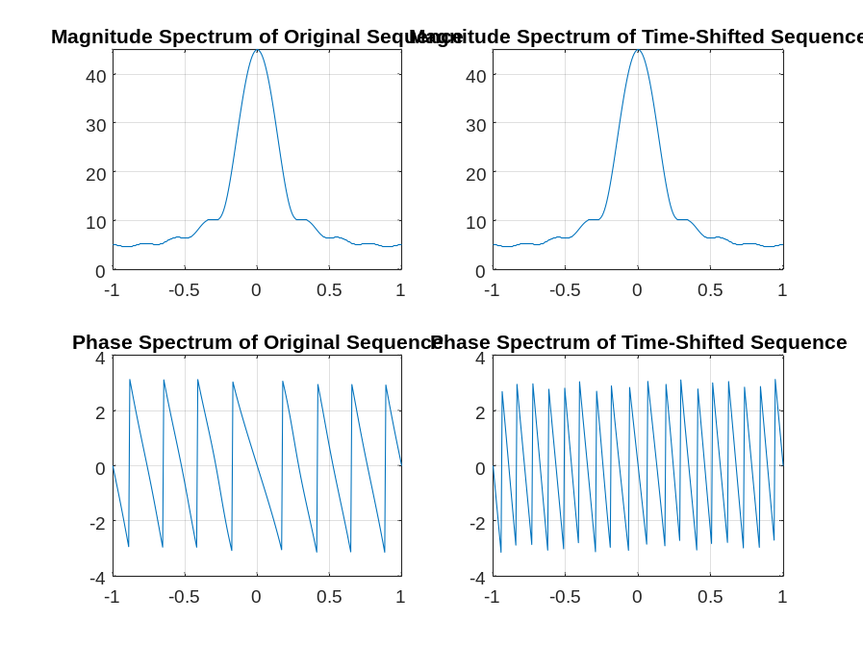
From these plots we make the following observations: The effect is to add phase, which makes the slope of the phase function steeper
Q3.8 Program P3_2 was run for the following value of the time-shift D = 4
The plots generated by running the modified program are given below:
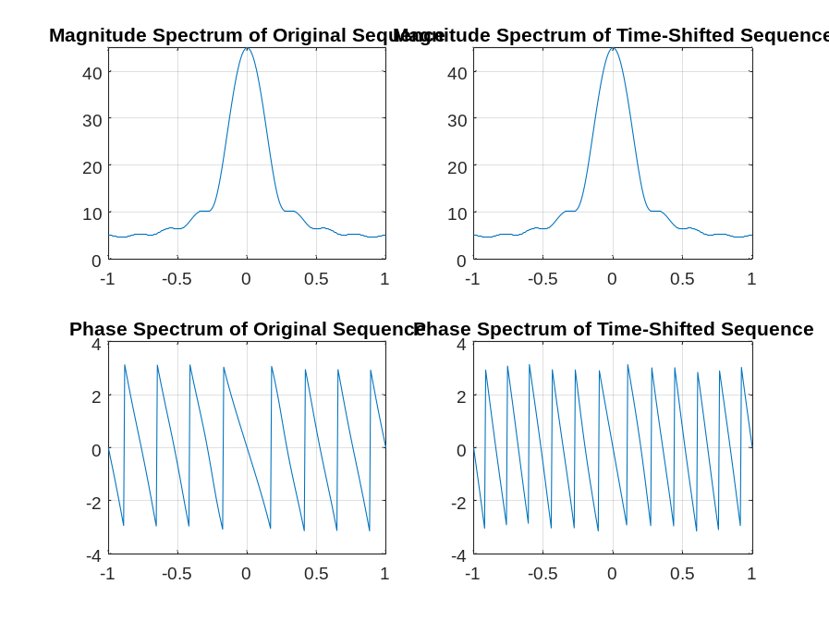
From these plots we make the following observations: There is a very significant change to the phase. As before, the time shift adds phase to the DTFT, making the slope of the phase spectrum steeper. However, in this case with D=4 instead of D=10, the (negative increase in the slope is less than it was before.
Q3.9 Program P3_2 was run for the following values of the time-shift and for the following values of length for the sequence
Length 5, time shift D = 3
Length 10, time shift D = 10
The plots generated by running the modified program are given below:
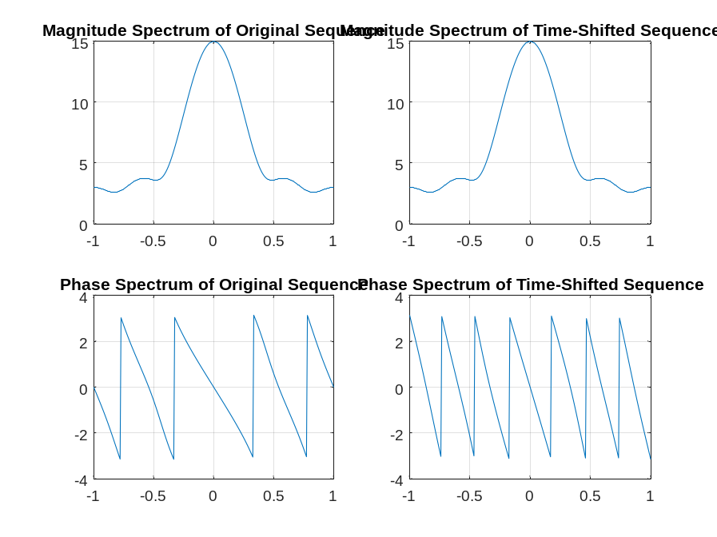
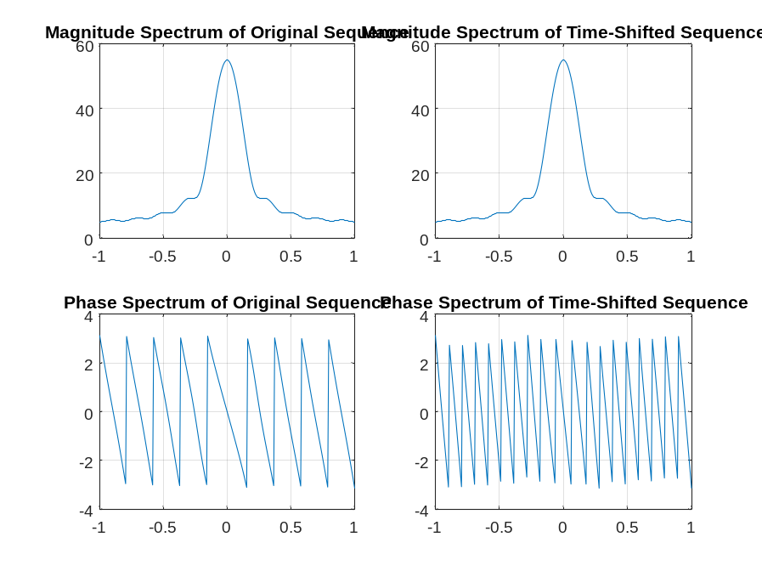
From these plots we make the following observations: Increasing the length makes the magnitude spectrum more narrow (i.e., makes the signal more “low pass”). It also makes the phase steeper (i.e., the slope more negative). This is because, if we think of the sequence as the impulse response of an LTI system, increasing the length adds more delay between the input and output of the system. As before, the time shift does not have any effect on the magnitude spectrum. However, it makes the slope of the phase spectrum more negative. The larger the value of the delay, the more negative slope is added to the phase spectrum.
Q3.10 The modified Program P3_3 created by adding appropriate comment statements, and adding program statements for labeling the two axes of each plot being generated by the program is given below:
% Program P3_3
% Frequency-Shifting Properties of DTFT
clf;
w = -pi:2*pi/255:pi; wo = 0.4*pi;
num1 = [1 3 5 7 9 11 13 15 17];
L = length(num1);
h1 = freqz(num1, 1, w);
n = 0:L-1;
num2 = exp(wo*i*n).*num1;
h2 = freqz(num2, 1, w);
subplot(2,2,1)
plot(w/pi,abs(h1));grid
title('Magnitude Spectrum of Original Sequence')
subplot(2,2,2)
plot(w/pi,abs(h2));grid
title('Magnitude Spectrum of Frequency-Shifted Sequence')
subplot(2,2,3)
plot(w/pi,angle(h1));grid
title('Phase Spectrum of Original Sequence')
subplot(2,2,4)
plot(w/pi,angle(h2));grid
title('Phase Spectrum of Frequency-Shifted Sequence')
The parameter controlling the amount of frequency-shift is wo
Q3.11 The plots generated by running the modified program are given below:
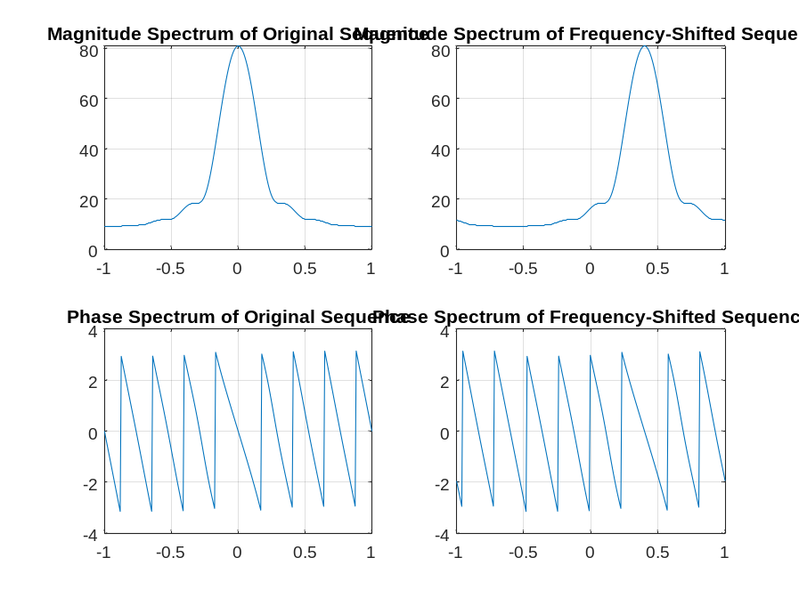
From these plots we make the following observations: Both the magnitude and phase spectra are shifted right by wo, which is given by 0.4 in this case.
Q3.12 Program P3_3 was run for the following value of the frequency-shift wo = -0.6
The plots generated by running the modified program are given below:
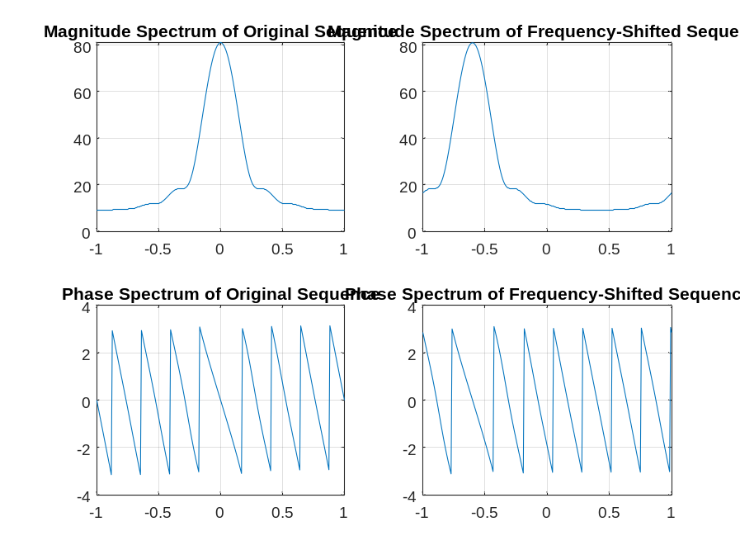
From these plots we make the following observations: The magnitude and phase spectra are shifted left by 3/5 rad.
Q3.13 Program P3_3 was run for the following values of the frequency-shift and for the following values of length for the sequence
Length 5, frequency shift wo=
Length 16, frequency shift wo = -0.2
The plots generated by running the modified program are given below:
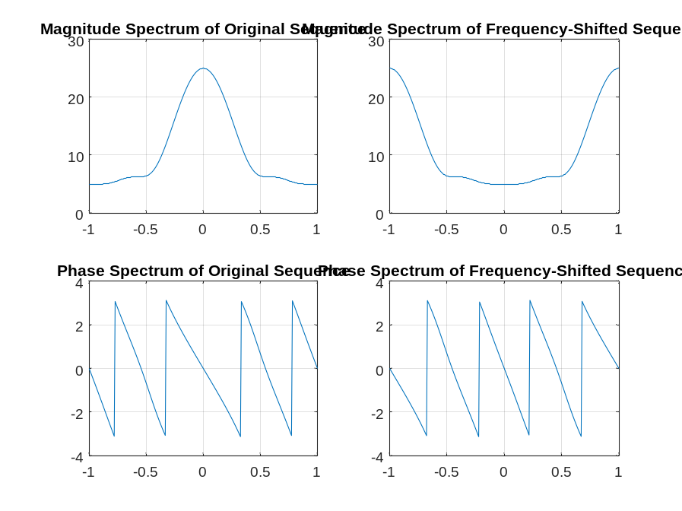
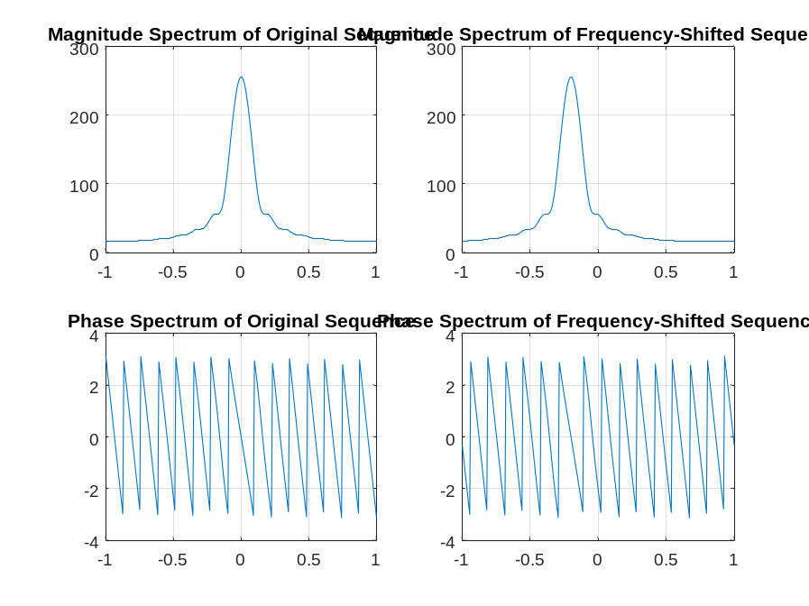
From these plots we make the following observations: The original sequences have a low pass characteristic. As before with the time shift property, a shorter length gives a broader low pass magnitude spectrum, whereas a longer length results in a low pass magnitude spectrum that is more narrow.
Q3.14 The modified Program P3_4 created by adding appropriate comment statements, and adding program statements for labeling the two axes of each plot being generated by the program is given below:
% Program P3_4
% Convolution Property of DTFT
clf;
w = -pi:2*pi/255:pi;
x1 = [1 3 5 7 9 11 13 15 17];
x2 = [1 -2 3 -2 1];
y = conv(x1,x2);
h1 = freqz(x1, 1, w);
h2 = freqz(x2, 1, w);
hp = h1.*h2;
h3 = freqz(y,1,w);
subplot(2,2,1)
plot(w/pi,abs(hp));grid
title('Product of Magnitude Spectra')
subplot(2,2,2)
plot(w/pi,abs(h3));grid
title('Magnitude Spectrum of Convolved Sequence')
subplot(2,2,3)
plot(w/pi,angle(hp));grid
title('Sum of Phase Spectra')
subplot(2,2,4)
plot(w/pi,angle(h3));grid
title('Phase Spectrum of Convolved Sequence')
Q3.15 The plots generated by running the modified program are given below:
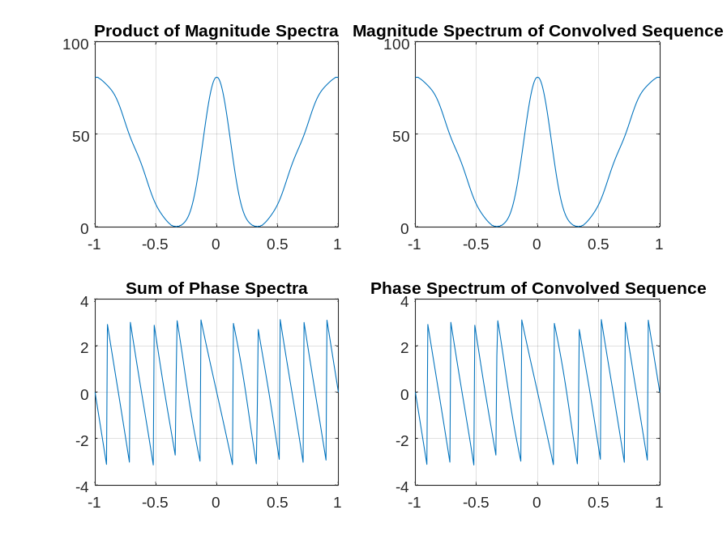
From these plots we make the following observations: The DTFT magnitude and phase spectra obtained by performing pointwise multiplication of the two DTFT’s of the original sequences are identical to those obtained by performing time domain convolution of the two original sequences; this verifies the convolution property of the DTFT
Q3.16 Program P3_4 was run for the following two different sets of sequences of varying lengths
1. Length of x1 = 10, x1[n] = (2/5)^n, 0<=n<=9; Length of x2 = 4, x2[n] = [0.25 0.25 0.25 0.25]
2. Length of x1 = 20, x1[n] = (-2/5)^n, 0<=n<=19; Length of x2 = 10, x2[n] = [1 3 5 7 9 11 13 15 17 19]
The plots generated by running the modified program are given below:
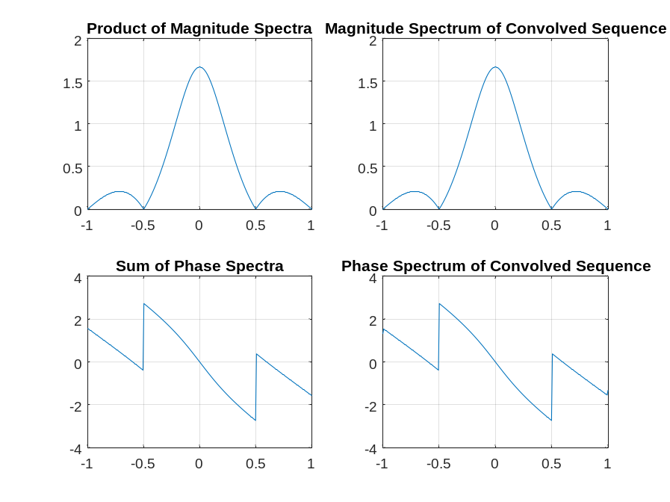
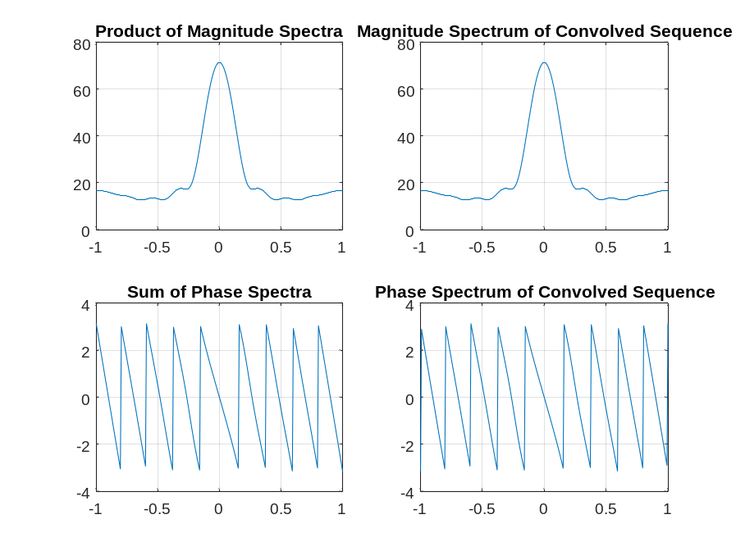
From these plots we make the following observations: The convolution property of the DTFT is again verified in both case. In each case, the DTFT magnitude and phase obtained by taking the pointwise products of the DTFT’s of the two original sequences are identical to the magnitude and phase spectra obtained from the DTFT of the time domain convolution of the two original sequences
Q3.17 The modified Program P3_5 created by adding appropriate comment statements, and adding program statements for labeling the two axes of each plot being generated by the program is given below:
% Program P3_5
% Modulation Property of DTFT
clf;
w = -pi:2*pi/255:pi;
x1 = [1 3 5 7 9 11 13 15 17];
x2 = [1 -1 1 -1 1 -1 1 -1 1];
y = x1.*x2;
h1 = freqz(x1, 1, w);
h2 = freqz(x2, 1, w);
h3 = freqz(y,1,w);
subplot(3,1,1)
plot(w/pi,abs(h1));grid
title('Magnitude Spectrum of First Sequence')
subplot(3,1,2)
plot(w/pi,abs(h2));grid
title('Magnitude Spectrum of Second Sequence')
subplot(3,1,3)
plot(w/pi,abs(h3));grid
title('Magnitude Spectrum of Product Sequence')
Q3.18 The plots generated by running the modified program are given below:
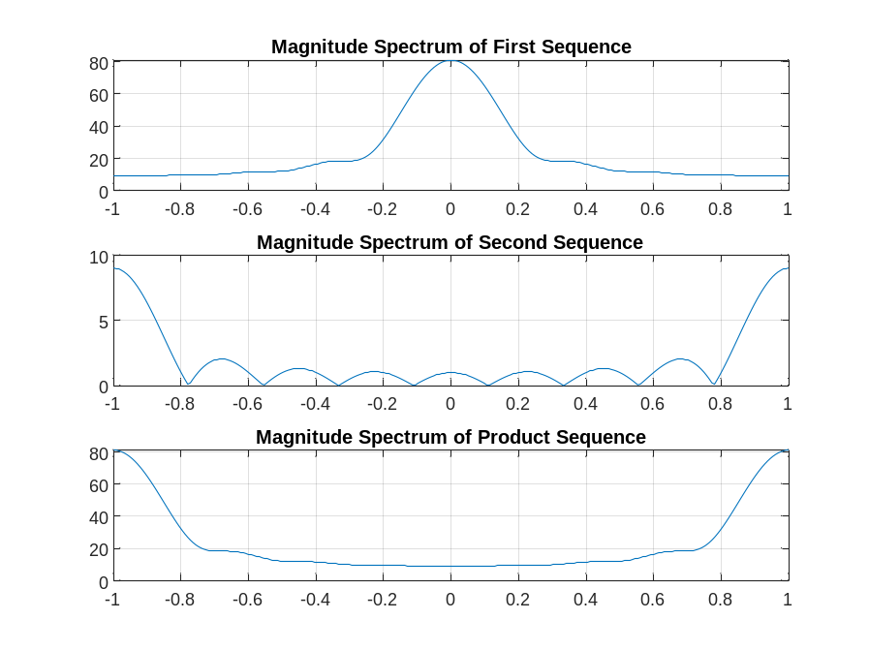
From these plots we make the following observations: The DTFT of the product sequence y is 1/2π times the convolution of the DTFT’s of the two sequences x1 and x2, as expected. The low-pass mainlobe of the DTFT of x1 combines with the high-pass mainlobe of the DTFT of x2 to produce a high-pass mainlobe centered at ±π in the magnitude spectrum of the product signal. The low-pass mainlobe of the DTFT of x1 combines with the low-pass sidelobes of the DTFT of x2 to produce a low-pass smooth region of relatively lower gain centered at DC in the magnitude spectrum of the product signal.
Q3.19 Program P3_5 was run for the following two different sets of sequences of varying lengths
1. Length of x1 = 10; x1[n] = (3/4)^n for 0 ≤ n ≤ 9;
Length of x2 = 10; x2[n]= [1/4 1/4 1/4 1/4 1/4 1/4 1/4 1/4 1/4 1/4]
2. Length of x1 = 16; x1[n] = (1/4)^n − for 0 ≤ n ≤ 15;
Length of x2 = 16; x2[n]= [1 3 5 7 9 11 13 15 0 0 0 0 0 0 0 0]
The plots generated by running the modified program are given below:
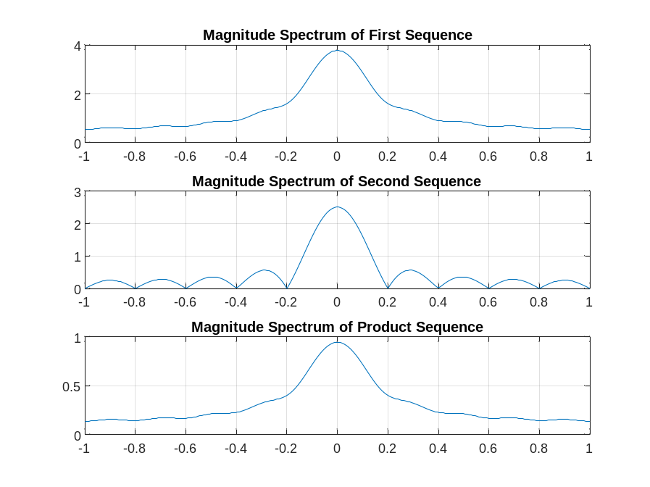
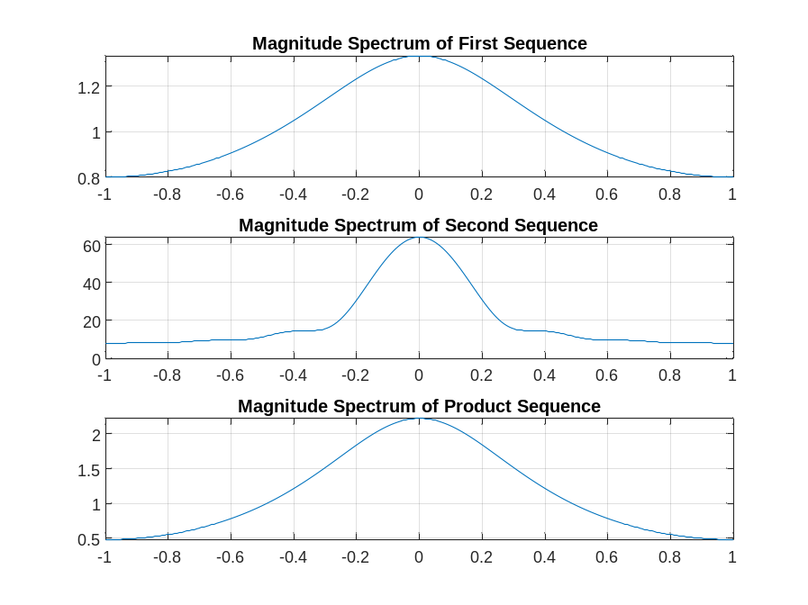
From these plots we make the following observations: In the first example, both x1 and x2 are low pass sequences. Moreover, the DTFT of x2 is a sync pulse. Taking the 22 product of these two sequences produces a new sequence y that is also low pass in character. The magnitude spectrum of y has a shape that is very similar to that of x1, but with some averaging. The spectral magnitude of y is reduced compared to that of x1, primarily due to the division by 2π that is inherent in the DTFT frequency convolution (time modulation) property. In the second example, x1 is high pass while x2 is low pass.
Q3.20 The modified Program P3_6 created by adding appropriate comment statements, and adding program statements for labeling the two axes of each plot being generated by the program is given below:
% Program P3_6
% Time Reversal Property of DTFT
clf;
w = -pi:2*pi/255:pi;
num = [1 2 3 4];
L = length(num)-1;
h1 = freqz(num, 1, w);
h2 = freqz(fliplr(num), 1, w);
h3 = exp(w*L*i).*h2;
subplot(2,2,1)
plot(w/pi,abs(h1));grid
title('Magnitude Spectrum of Original Sequence')
subplot(2,2,2)
plot(w/pi,abs(h3));grid
title('Magnitude Spectrum of Time-Reversed Sequence')
subplot(2,2,3)
plot(w/pi,angle(h1));grid
title('Phase Spectrum of Original Sequence')
subplot(2,2,4)
plot(w/pi,angle(h3));grid
title('Phase Spectrum of Time-Reversed Sequence')
The program implements the time-reversal operation as follows The original ramp sequence is nonzero for 0 ≤ n ≤ 3. A new sequence is formed by using fliplr; this new sequence contains the samples of the original ramp sequence in time reversed order. However, the new sequence is still nonzero for 0 ≤ n ≤ 3, whereas the time reversed ramp sequence must be nonzero for -3 ≤ n ≤ 0. This required left shift in time is accomplished in the frequency domain using the time shift property of the DTFT as follows. First, freqz is called to set h2 equal to the DTFT of the new sequence obtained from calling fliplr on the original ramp sequence. Finally, h3 is set equal to the DTFT of the time reversed ramp by multiplying h2 times a linear phase term to implement the required left shift in the time domain.
Q3.21 The plots generated by running the modified program are given below:
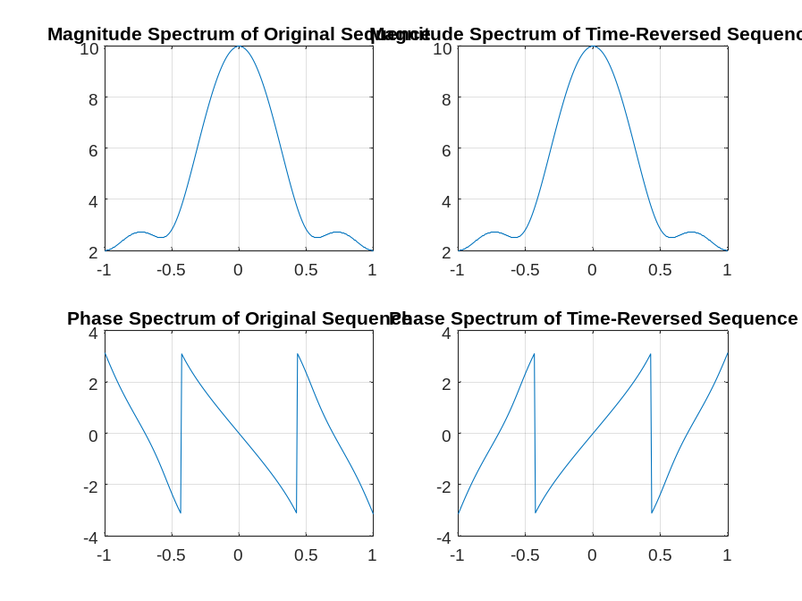
From these plots we make the following observations: Both the original and time reversed ramp sequences are real-valued. Therefore, they have conjugate symmetric DTFT’s. For both sequences, this implies that the magnitude spectrum is even symmetric and the phase spectrum is odd symmetric. Now, the DTFT of the time reversed ramp (h3) is equal to a frequency reversed version of the DTFT of the original sequence (h1). Since “flipping” an even function has no net effect, we see in the graphs above that both the original and time reversed sequences have identical magnitude spectra.
Q3.22 Program P3_6 was run for the following two different sets of sequences of varying lengths
Length of num = 8; num = (1/2)^n for 0 ≤ n ≤ 7
Length of num = 16; num = (-3/2)^n − for 0 ≤ n ≤ 15
The plots generated by running the modified program are given below:
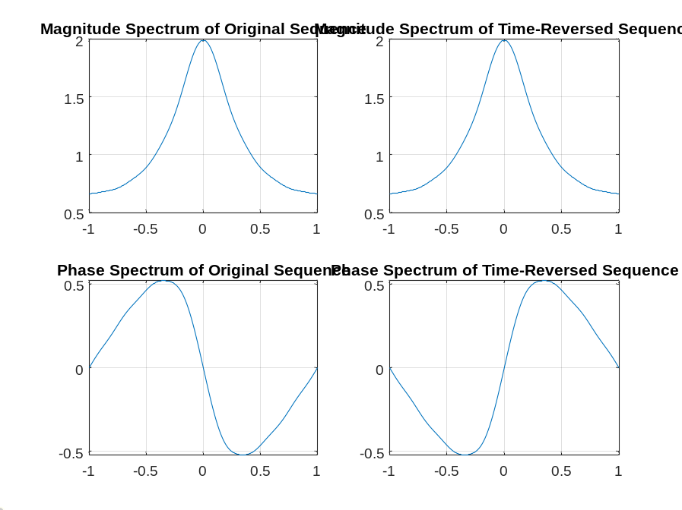
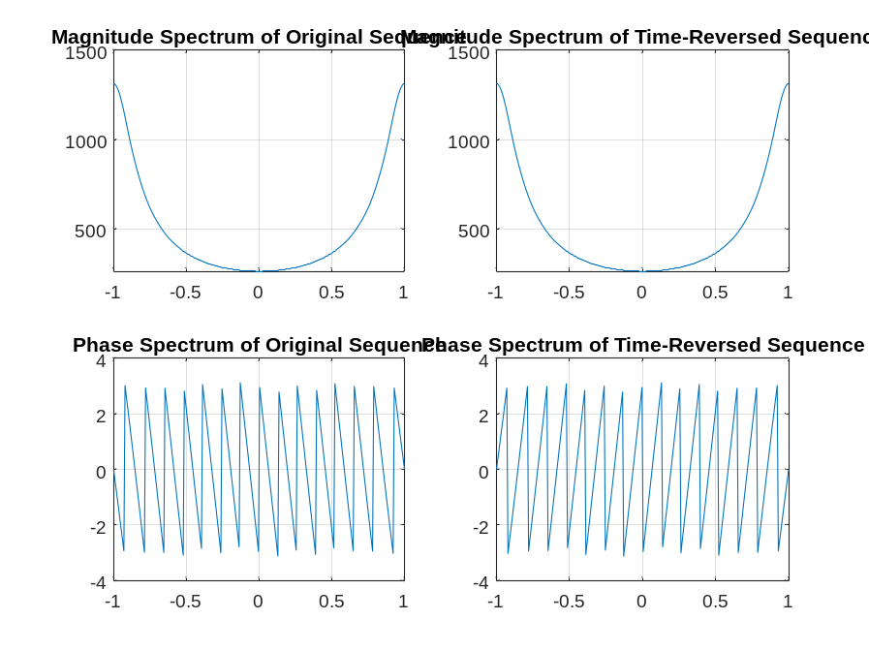
From these plots we make the following observations: As before in Q3.20, we see that the DTFT of the time reversed sequence is a frequency reversed version of the DTFT of the original sequence. In particular, because these are real-valued sequences with even magnitude spectra and odd phase spectra, the magnitude spectra of the original and time reversed sequences are the same. However, the phase spectrum of the time reversed sequence is a frequency reversed version of the phase spectrum of the original sequence.
Project 3.4 DFT Properties
Answers:
Q3.26 The purpose of the command rem in the function circshift is rem(a,b) returns the remainder after division of a by b
Q3.27 The function circshift operates as follows: The input sequence x is circularly shifted left by M positions. If M > 0, then circshift removes the leftmost M elements from the vector x and appends them on the right side of the remaining elements to obtain the circularly shifted sequence. If If M < 0, then circshift first complements M by the length of x, i.e., the rightmost length(x)-M samples are removed from x and appended on the right of the remaining M samples to obtain the circularly shifted sequence
Q3.28 The purpose of the operator ~= in the function circonv is This is the binary relational NOT EQUAL operator. A ~= B returns the value 1 if A and B are unequal and the value 0 if A and B are equal.
Q3.29 The function circonv operates as follows: The input is two vectors x1 and x2 of equal length L. To understand how circonv works, it is useful to think in terms of the periodic extension of x2. Let x2p be the infinite-length periodic extension of x2. Conceptually, the routine time reverses x2p and sets x2tr equal to elements 1 through L of the time reversed version of x2p. Elements 1 through L of the output vector y are then obtained by taking the inner product between x1 and a length L vector sh obtained by circularly shifting right the time reversed vector x2tr. For the output sample y[n], 1 ≤ n ≤ L, the amount of the right circular shift is n-1 positions.
Q3.30 The modified Program P3_7 created by adding appropriate comment statements, and adding program statements for labeling each plot being generated by the program is given below:
% Program P3_7
% Illustration of Circular Shift of a Sequence
clf;
M = 6;
a = [0 1 2 3 4 5 6 7 8 9];
b = circshift(a,M);
L = length(a)-1;
n = 0:L;
subplot(2,1,1);
stem(n,a);axis([0,L,min(a),max(a)]);
title('Original Sequence');
subplot(2,1,2);
stem(n,b);axis([0,L,min(a),max(a)]);
title(['Sequence Obtained by Circularly Shifting by ',num2str(M),' Samples']);
The parameter determining the amount of time-shifting is M
If the amount of time-shift is greater than the sequence length then The circular shift actually implemented is rem(M,length(a)) positions left, which is equivalent to circularly shifting by M positions (more than once around) and also to shifting left by M the periodic extension of the sequence.
Q3.31 The plots generated by running the modified program are given below:
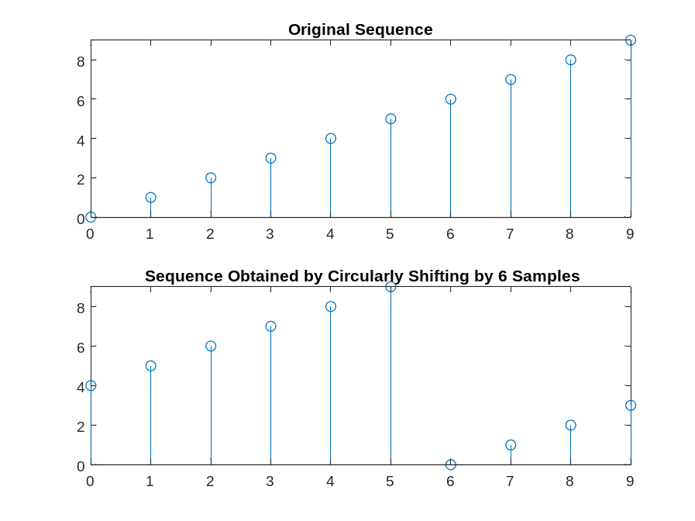
From these plots we make the following observations: Here, the length of the sequence is 10 samples and we have M=12. This may be interpreted alternatively as a circular shift left by 12 positions (more than once around), as a circular shift left by 12-10 = 2 positions, or as a linear shift left by 2 or by 12 of the periodic extension of the sequence.
Q3.32 The modified Program P3_8 created by adding appropriate comment statements, and adding program statements for labeling each plot being generated by the program is given below:
% Program P3_8
% Circular Time-Shifting Property of DFT
clf;
x = [0 2 4 6 8 10 12 14 16];
N = length(x)-1; n = 0:N;
y = circshift(x,5);
XF = fft(x);
YF = fft(y);
subplot(2,2,1)
stem(n,abs(XF));grid
title('Magnitude of DFT of Original Sequence');
subplot(2,2,2)
stem(n,abs(YF));grid
title('Magnitude of DFT of Circularly Shifted Sequence');
subplot(2,2,3)
stem(n,angle(XF));grid
title('Phase of DFT of Original Sequence');
subplot(2,2,4)
stem(n,angle(YF));grid
title('Phase of DFT of Circularly Shifted Sequence');
The amount of time-shift is hard coded in this program at 5 samples to the left.
Q3.33 The plots generated by running the modified program are given below:
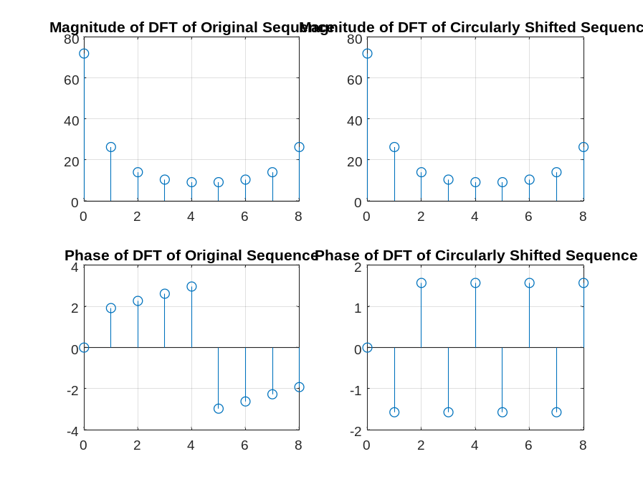
From these plots we make the following observations: the length of the sequence is N=8 and the time shift is an advance by five samples to the left. The phase tern introduced by this time shift is . This is a substantial shift that dramatically increases the slope of the spectral phase. Whereas the original phase function has only one branch cut, there are five branch cuts in the spectral phase of the shifted signal.
Q3.34 The plots generated by running the modified program for the following two different amounts of time-shifts, with the amount of shift indicated, are shown below:

M = 2
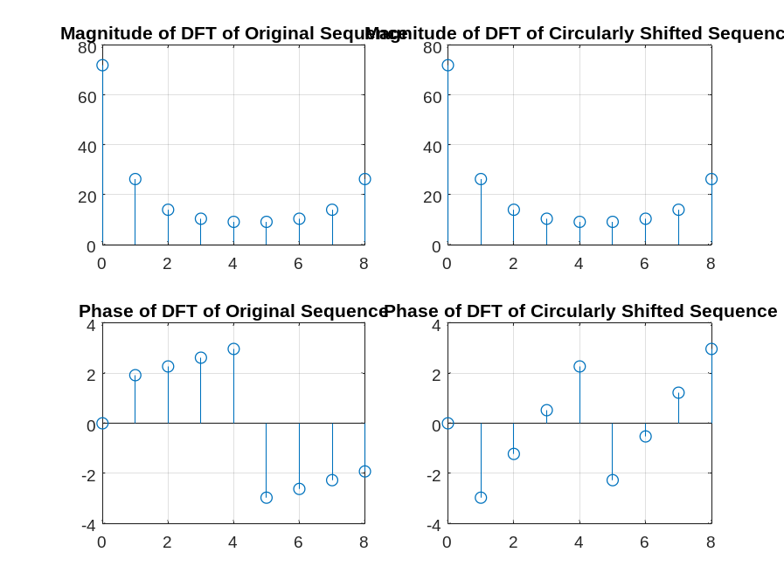
M = -2
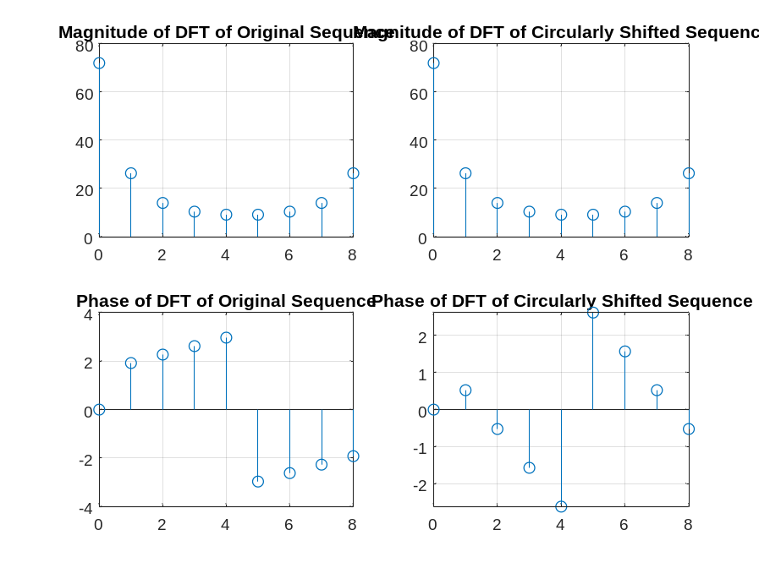
From these plots we make the following observations: In all cases, the spectral magnitude is not affected by the shift. For the first example, the time shift is a circular shift left by 2 samples. This introduces an increased slope to the spectral phase that is significantly less than what we saw in Q3.33. In the second example, the shift is circular shift right by 2 samples (M=-2). This cancels the positive slope seen in the spectral phase of the original sequences and results in a moderate negative slope.
Q3.35 The plots generated by running the modified program for the following two different sequences of different lengths, with the lengths indicated, are shown below:
Length = 16
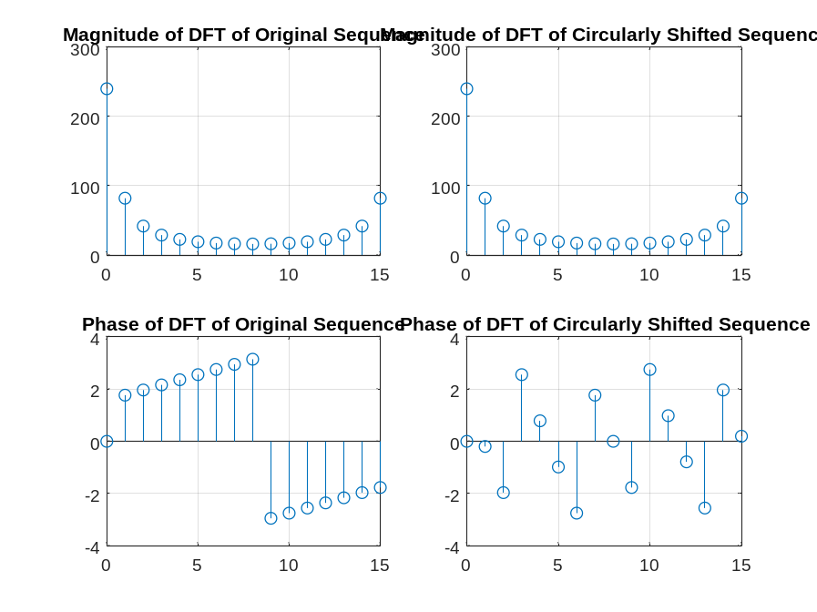
Length = 24
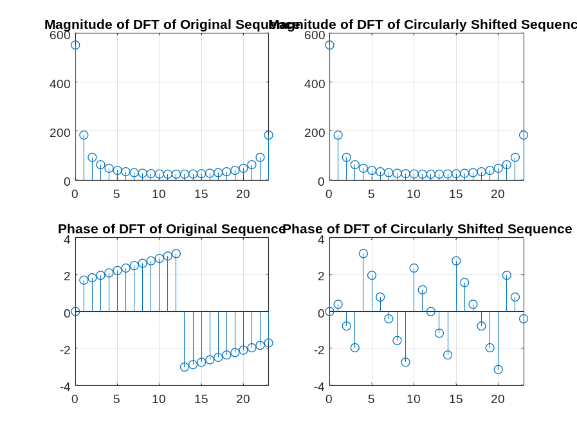
From these plots we make the following observations: In the first example, the sequence is real and periodically (circularly) even, so the phase takes only the two values zero and π. The shift is a circular shift to the right by 2 (M=-2), which is seen to induce a negative slope to the phase. In the second example, the signal is given by (0.75)n − and the shift is again M=-2 which again introduces a negative slope in the phase.
Q3.36 A copy of Program P3_9 is given below along with the plots generated by running this program:
% Program P3_9
% Circular Convolution Property of DFT
g1 = [1 2 3 4 5 6]; g2 = [1 -2 3 3 -2 1];
ycir = Circonv(g1,g2);
disp('Result of circular convolution = ');disp(ycir)
G1 = fft(g1); G2 = fft(g2);
yc = real(ifft(G1.*G2));
disp('Result of IDFT of the DFT products = ');disp(yc)
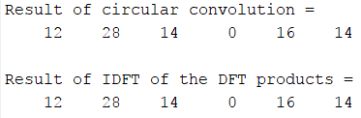
From these plots we make the following observations: The DFT of a circular convolution is the pointwise products of the DFT’s.
Q3.37 Program P3_9 was run again for the following two different sets of equal-length sequences:
The plots generated are shown below:
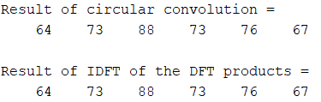
From these plots we make the following observations:
Q3.38 A copy of Program P3_10 is given below along with the plots generated by running this program:
% Program P3_10
% Linear Convolution via Circular Convolution
g1 = [1 2 3 4 5];g2 = [2 2 0 1 1];
g1e = [g1 zeros(1,length(g2)-1)];
g2e = [g2 zeros(1,length(g1)-1)];
ylin = Circonv(g1e,g2e);
disp('Linear convolution via circular convolution = ');disp(ylin);
y = conv(g1, g2);
disp('Direct linear convolution = ');disp(y)
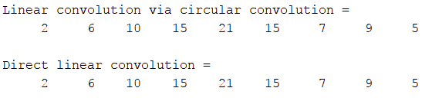
From these plots we make the following observations: zero padding to the appropriate length does indeed make it possible to implement linear convolution using circular convolution.
Q3.39 Program P3_10 was run again for the following two different sets of sequences of unequal lengths:
The plots generated are shown below:
g1 = [2 1 4 3 5 6];g2 = [1 1 0 2 2];

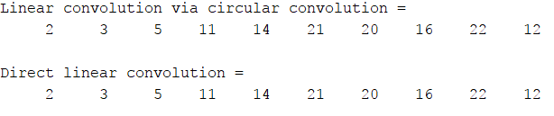
g1 = [6 5 4 3 2 1];g2 = [2 1 0 0 1];
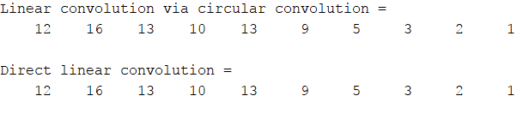
From these plots we make the following observations: You can implement the linear convolution of two sequences by zero padding them to the sum of their lengths less one and then invoking circular convolution on the zero padded sequences.
Q3.40 The MATLAB program to develop the linear convolution of two sequences via the DFT of each is given below:
% Program Q3.40
% Linear Convolution via Circular Convolution
g1 = [1 2 3 4 5];g2 = [2 2 0 1 1];
g1e = [g1 zeros(1,length(g2)-1)];
g2e = [g2 zeros(1,length(g1)-1)];
G1EF = fft(g1e);
G2EF = fft(g2e);
ylin = real(ifft(G1EF.*G2EF));
disp('Linear convolution via circular convolution =');disp(ylin);
The plots generated by running this program for the sequences of Q3.38 are shown below:
From these plots we make the following observations: The result is the same as before in Q3.38; in other words, it works as advertised
The plots generated by running this program for the sequences of Q3.39 are shown below:
g1 = [2 1 4 3 5 6];g2 = [1 1 0 2 2];
g1 = [6 5 4 3 2 1];g2 = [2 1 0 0 1];
From these plots we make the following observations: The results are the same as those that were obtained before when the DFT was not used.
Q3.41 A copy of Program P3_11 is given below:
% Program P3_11
% Relations between the DFTs of the Periodic Even
% and Odd Parts of a Real Sequence
x = [1 2 4 2 6 32 6 4 2 zeros(1,247)];
x1 = [x(1) x(256:-1:2)];
xe = 0.5 *(x + x1);
XF = fft(x);
XEF = fft(xe);
clf;
k = 0:255;
subplot(2,2,1);
plot(k/128,real(XF)); grid;
ylabel('Amplitude');
title('Re(DFT\{x[n]\})');
subplot(2,2,2);
plot(k/128,imag(XF)); grid;
ylabel('Amplitude');
title('Im(DFT\{x[n]\})');
subplot(2,2,3);
plot(k/128,real(XEF)); grid;
xlabel('Time index n');ylabel('Amplitude');
title('Re(DFT\{x_{e}[n]\})');
subplot(2,2,4);
plot(k/128,imag(XEF)); grid;
xlabel('Time index n');ylabel('Amplitude');
title('Im(DFT\{x_{e}[n]\})');
The relation between the sequence x1[n] and x[n] is x1[n] is a periodically time reversed version of x[n]

Q3.42 The plots generated by running Program P3_11 are given below:
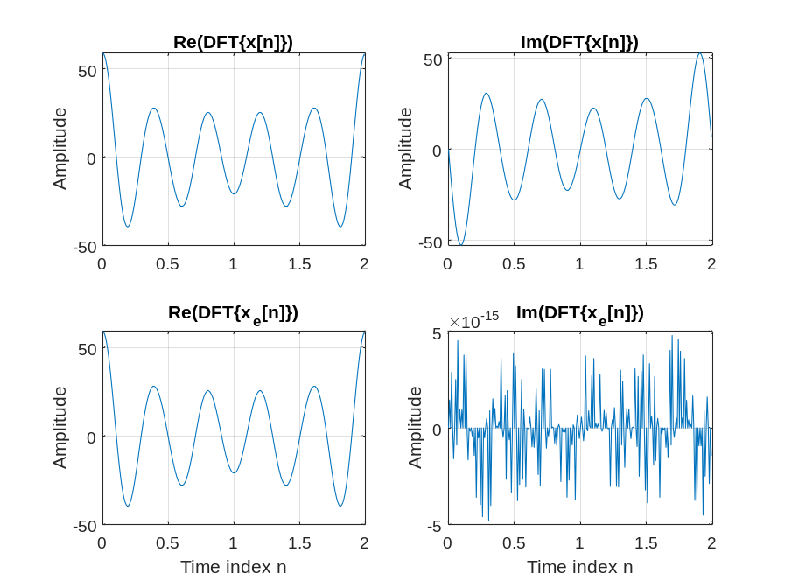
The imaginary part of XEF is/is not equal to zero. This result can be explained as follows: This result can be explained as follows: The real part of the transform of x[n] is the transform of the periodically even part of x[n]. Therefore, the DFT of the periodically even part of x[n] has a real part that is precisely the real part of X[k] and an imaginary part that is zero.
Q3.43 The required modifications to Program P3_11 to verify the relation between the DFT of the periodic odd part and the imaginary part of XEF are given below along with the plots generated by running this program:
% Program Q3.43
% Relations between the DFTs of the Periodic Even
% and Odd Parts of a Real Sequence
x = [1 2 4 2 6 32 6 4 2 zeros(1,247)];
x1 = [x(1) x(256:-1:2)];
xo = 0.5 *(x - x1);
XF = fft(x);
XOF = fft(xo);
clf;
k = 0:255;
subplot(2,2,1);
plot(k/128,real(XF)); grid;
ylabel('Amplitude');
title('Re(DFT\{x[n]\})');
subplot(2,2,2);
plot(k/128,imag(XF)); grid;
ylabel('Amplitude');
title('Im(DFT\{x[n]\})');
subplot(2,2,3);
plot(k/128,real(XOF)); grid;
xlabel('Time index n');ylabel('Amplitude');
title('Re(DFT\{x_{o}[n]\})');
subplot(2,2,4);
plot(k/128,imag(XOF)); grid;
xlabel('Time index n');ylabel('Amplitude');
title('Im(DFT\{x_{o}[n]\})');

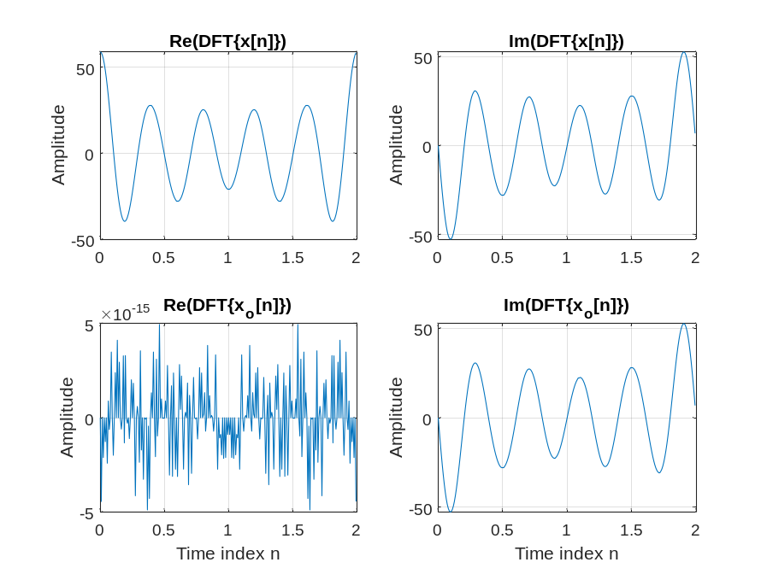
From these plots we make the following observations: The DFT of the periodically odd part of x[n] is precisely the imaginary part of the DFT of x[n]. Therefore, the DFT of the periodically odd part of x[n] has a real part that is zero to within floating point precision and an imaginary part that is precisely the imaginary part of the DFT of x[n].
Q3.44 A copy of Program P3_12 is given below:
% Program P3_12
% Parseval's Relation
x = [(1:128) (128:-1:1)];
XF = fft(x);
a = sum(x.*x)
b = round(sum(abs(XF).^2)/256)
The values for a and b we get by running this program are
a = 1414528
b = 1414528

Q3.45 The required modifications to Program P3_11 are given below:
% Program Q345
% Parseval's Relation
x = [(1:128) (128:-1:1)];
XF = fft(x);
a = sum(x.*x)
b = round(sum(XF.*conj(XF))/256)
3.3 z-TRANSFORM
Project 3.5 Analysis of z-Transforms
Answers:

Q3.46 The frequency response of the z-transform obtained using Program P3_1 is plotted below:
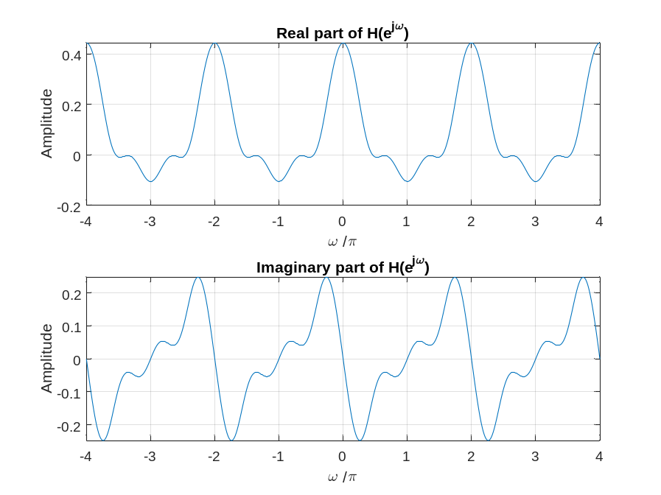
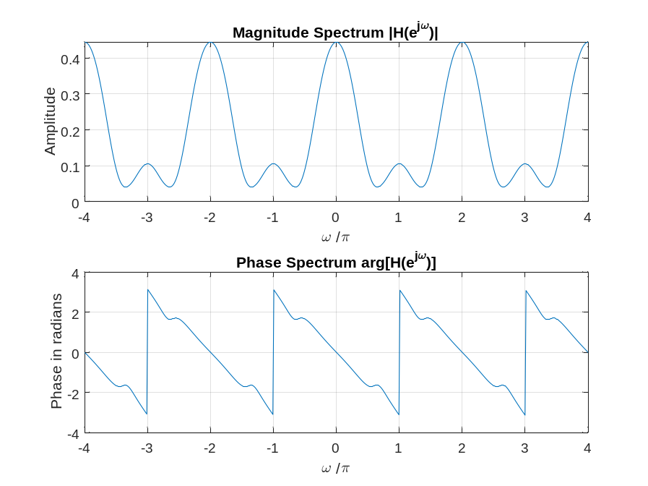
Q3.47 The MATLAB program to compute and display the poles and zeros, to compute and display the factored form, and to generate the pole-zero plot of a rational z-transform is given below:
% Program Q347
% Evaluation of the DTFT
clf;
% Compute the frequency samples of the DTFT
w = -4*pi:8*pi/511:4*pi;
num = [2 5 9 5 3];den = [5 45 2 1 1];
[z,p,k] = tf2zpk(num, den);
disp('Zeros:');
disp(z);
disp('Poles:');
disp(p);
[sos k] = zp2sos(z,p,k);
disp('SOS:');
disp(sos);
disp('k:');
disp(k);
zplane(z,p);

Using this program we obtain the following results on the z-transform G(z) of Q3.46:
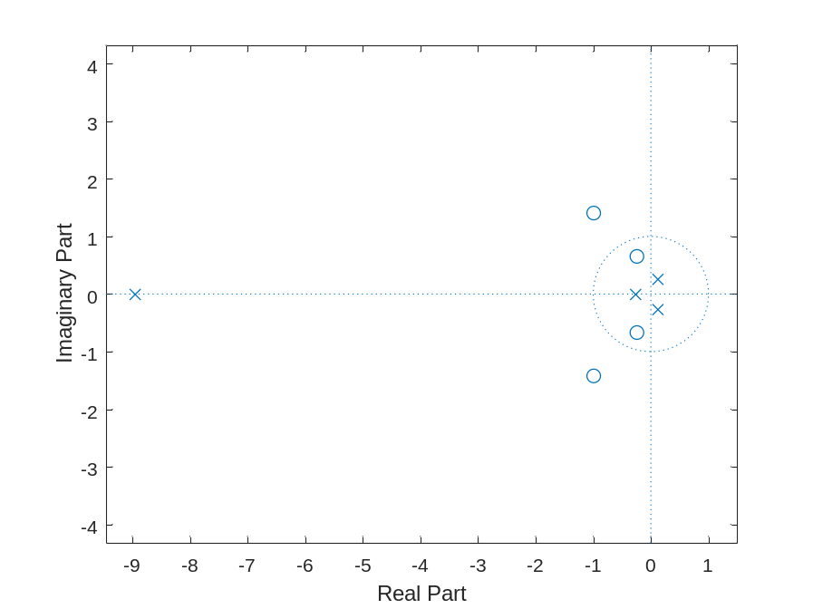
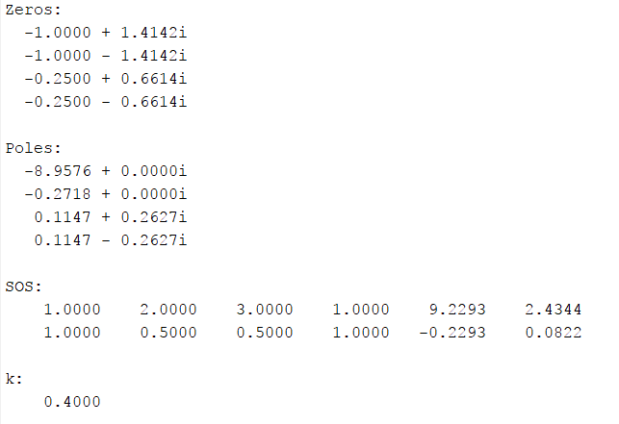
Q3.48 From the pole-zero plot generated in Question Q3.47, the number of regions of convergence (ROC) of G(z) are FOUR.
Note: the magnitude of the complex conjugate poles inside the unit circle is 0.2866
All possible ROCs of this z-transform are sketched below:
From the pole-zero plot it can be seen that the DTFT: The DTFT doese exist for the sequence obtained by using the ROC shown above. This would be a stable system with a two-sided impulse response

Q3.49 The MATLAB program to compute and display the rational z-transform from its zeros, poles and gain constant is given below:
% Program Q349
% Evaluation of the DTFT
clf;
% Compute the frequency samples of the DTFT
z = [0.3; 2.5; -0.2+0.4*i; -0.2-0.4*i];
p = [0.5; -0.75; 0.6+0.7*i; 0.6-0.7*i];
k = 3.9;
[num den] = zp2tf(z,p,k)
The rational form of a z-transform with the given poles, zeros, and gain is found to be
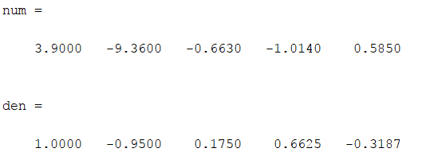
Project 3.6 Inverse z-Transform
Answers:
Q3.50 The MATLAB program to compute the first L samples of the inverse of a rational z-transform is given below:
% Program Q350
% Evaluation of the DTFT
clf;
% Compute the frequency samples of the DTFT
num = [2 5 9 5 3];
den = [5 45 2 1 1];
L = input('L: ');
[g t]=impz(num,den,L);
stem(t,g);
title('First 50 samples of impulse response');
xlabel('Time Index n');
ylabel('h[n]');

The plot of the first 50 samples of the inverse of G(z) of Q3.46 obtained using this program is sketched below:
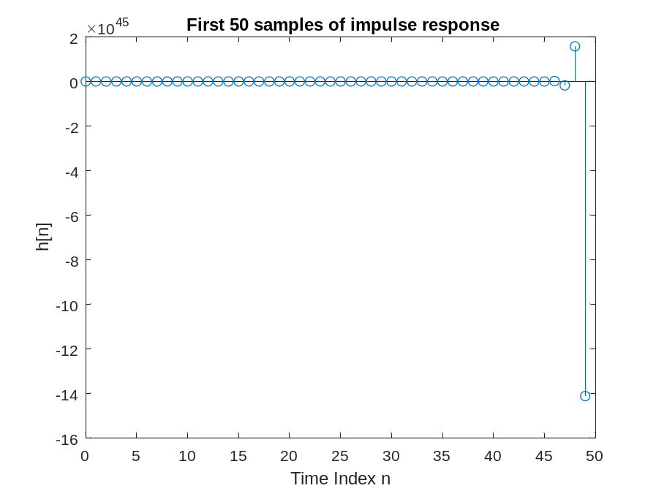
Q3.51 The MATLAB program to determine the partial-fraction expansion of a rational z-transform is given below:
% Program Q351
% Evaluation of the DTFT
% Compute the frequency samples of the DTFT
clf;
% initialize
num = [2 5 9 5 3];
den = [5 45 2 1 1];
% partial fraction expansion
[r p k] = residuez(num,den)
The partial-fraction expansion of G(z) of Q3.46 obtained using this program is shown below:
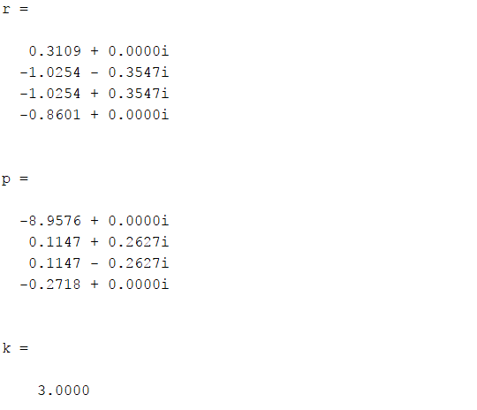

From the above partial-fraction expansion we arrive at the inverse z-transform g[n] as shown below:
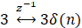
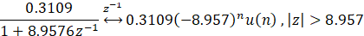
With:
Let a = , b =
Let
Then may be written:
After some algebra,
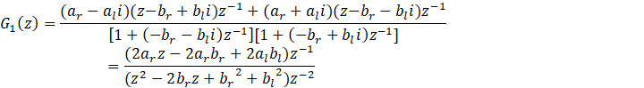
According to the formula:
Making the associations , we obtain
whereupon may be written as:
The inverse z-transform of is given by
2
Plugging back into the definitions of a , b , r , and , we have for the inverse ztransform of the term
All together, the required inverse z-transform is given by:
g[n]=
Date: 10/2024 Signature: Nguyễn Đình Khánh Vy

